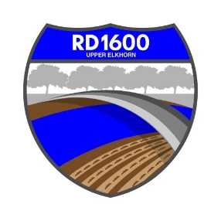
NOTICE SPECIAL MEETING OF THE
BOARD OF TRUSTEES OF RECLAMATION DISTRICT NO. 1600

Tuesday, August 8, 2023 @ 3:00 PM
Bypass Farms, 14130 County Road 117, West Sacramento, CA

Call to Order:

Introductions

Determine if quorum is present

Report by MBK Engineers on Maintenance and Related Matters

Flood System Repair Program (FSRP) including cost share by District

Vegetation Control

DWR Road Repair

FEMA Claim

Repair of 75 hp Pump and Related Pump Issues

Deferred Maintenance Program

Other On-Going Maintenance Matters

CLOSED SESSION: Conference with Legal Counsel – Anticipated Litigation. Significant exposure to litigation pursuant to subdivision (b) of Section 54956.9 (one case)

Action Items:

Completion of Special Districts and Other Agencies Authorization Form for FY 2023-2024 for Yolo County

Approval of Minutes

Meeting 6.7.2023

Special Meeting 6.27.2023

Special Meeting 7.24.2023
- Report by Legal Counsel
- Reports by Trustees
- Scheduling Next Meeting

Dated: August 4, 2023

Posted by Ammy Reyes
District Secretary
Reclamation District No. 1600

PROOF OF POSTING NOTICE OF SPECIAL MEETING

I am a citizen of the United States and a resident of Yolo County,
California. I am over the age of eighteen years. On August __, 2023, I posted within the boundaries of the District of RECLAMATION DISTRICT NO. 1600 the NOTICE OF SPECIAL MEETING OF RECLAMATION DISTRICT NO. 1600.

I declare under penalty of perjury under the laws of the State of California

that the foregoing is true and correct.
Executed on August _____, 2023, at ______________, California.

Ammy Reyes, Secretary
Reclamation District No. 1600

