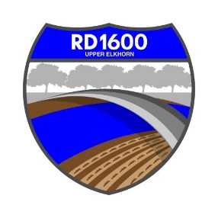
NOTICE SPECIAL MEETING OF THE
BOARD OF TRUSTEES OF RECLAMATION DISTRICT NO. 1600

Tuesday, May 30, 2023 @ 4:00 PM
Bypass Farms, 14130 County Road 117, West Sacramento, CA

Call to Order:

Introductions

Determine if quorum is present
2. CLOSED SESSION: Conference with Legal Counsel – Anticipated Litigation. Significant exposure to litigation pursuant to subdivision (b) of Section 54956.9 (one case)

Dated: May 25, 2023

Posted by Ammy Reyes
District Secretary
Reclamation District No. 1600

PROOF OF POSTING NOTICE OF SPECIAL MEETING

I am a citizen of the United States and a resident of Yolo County,
California. I am over the age of eighteen years. On May 26, 2023, I posted within the boundaries of the District of RECLAMATION DISTRICT NO. 1600 the NOTICE OF SPECIAL MEETING OF RECLAMATION DISTRICT NO. 1600.

I declare under penalty of perjury under the laws of the State of California

that the foregoing is true and correct.
Executed on May 26, 2023, at West Sacramento, California.

Ammy Reyes, Secretary
Reclamation District No. 1600

