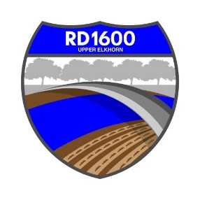
NOTICE OF REGULAR MEETING OF THE
BOARD OF TRUSTEES OF RECLAMATION DISTRICT NO. 1600
Monday, December 5, 2022 at 10:00 AM
Bypass Farms, 14130 County Road 117, West Sacramento, CA

Call to Order - Determine if quorum is present

Public Comment on Non-Agenda items.

- Action Items:
a. Review and approval of the minutes of September 13, 2022 regular meeting.

b. Review and approval of financial reports prepared by District accountant (Dustin Dumars).

c. FMAP 2022 Action Item:
i) Consideration of Resolution 2022-XX-XX to authorize the President to execute documentation for 2022 FMAP (attached exhibit B from the application) and to act as necessary related to the application
ii). Consideration of Resolution 2022-XX-XX to Accept Funds under 2022-FMAP (attached exhibit E from the application)

d. Revise and approve updated County of Yolo, Department of Financial Services form following resignation of Kyle Lang

e. Review and approval of Record Retention & Disposal Policy
- Informational Items:
a. Updates and report by District Engineer

Flood Maintenance Program (FMAP)

Flood System Repair Projects (FSRP) Funding

Erosion Maintenance Landside Sacramento River Levee

US Army Corps of Engineers - System-Wide Improvement Framework (SWIF) Update

Department of Water Resources Levee Inspection Report – Fall 2022

Update on Upper Elkhorn and Tule Canal Feasibility Study

Update on Levee repairs by RD 2035 near intake facility

Update on matters that have arisen since last meeting
b. Discuss hiring a District Manager
c. Flood Training for Trustees – list of contact people?
d. Report by District attorney re ethics training and Form 700
e. Trustee comments
f. Received communications
Next regular meeting - proposed date Tuesday, March 7 at 4:00 pm

Dated: November 28, 2022

PROOF OF POSTING NOTICE OF REGULAR MEETING

I am a citizen of the United States and a resident of Yolo County, California. I am over the age of eighteen years.

On ___December 1______, 2022, I posted within the boundaries of the District of RECLAMATION DISTRICT NO. 1600 the NOTICE OF REGULAR MEETING OF RECLAMATION DISTRICT NO. 1600.

I declare under penalty of perjury under the laws of the State of California that the forgoing is true and correct.

Executed on _December 1______, 2022, at West Sacramento, California.

AMMY REYES, Secretary, RD 1600

